What can I do if I forget my password of Tenda Cloud account?

If you forget your password of Tenda Cloud account, please follow the steps as below.

Step1: Open the Tenda Beli app, click “Login”.

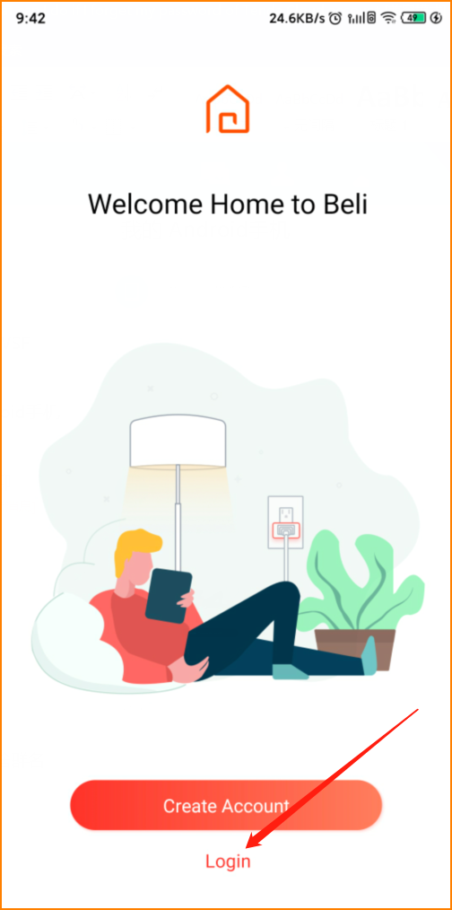

Step2: Tap “Forget password”, then enter your email address and click “Reset password”. Later you will receive an email from Tenda, click the url in that email, set your new password and confirm. Now you can login the Beli app.

